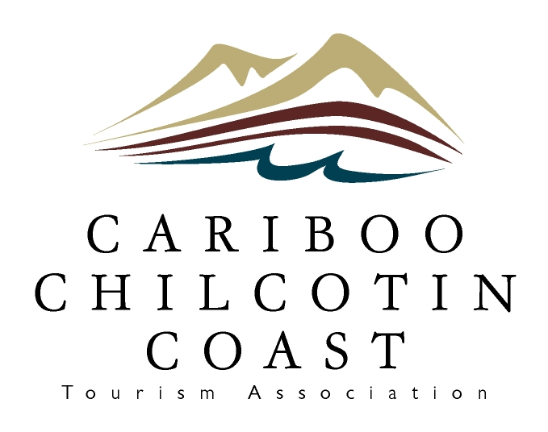

**Cariboo Chilcotin Coast Tourism**

**Marketing Association**

**Annual General Meeting Agenda**

**October 7, 2025 1:30 pm**

1. Call to Order – note session is recorded
2. Appointment of Recording Secretary
3. Adoption of Agenda
4. Adoption of October 17, 2024 Meeting Minutes
5. Auditor’s Report – Vohora LLP
6. Marketing Committee Report – Johannes Bodendorfer
7. Marketing Activities Report – Jenny Bakken & Isabelle Call
8. Questions from the Floor
9. Adjournment