**Cariboo Chilcotin Coast Tourism Association**

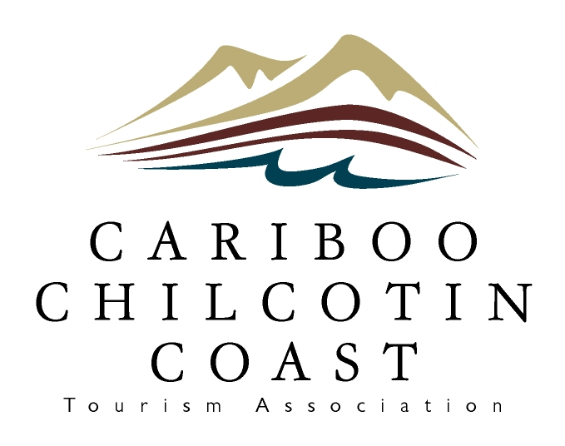

**Annual General Meeting Agenda**

**October 18, 2025 2:15 pm**

1. Call to Order
2. Appointment of Recording Secretary
3. Adoption of Agenda
4. Adoption of October 17, 2024 Meeting Minutes
5. Auditor’s Report – virtually by Vohora LLP
6. Chair’s Report – Shannon Lansdowne
7. Election of Directors
8. Questions from the Floor
9. Adjournment